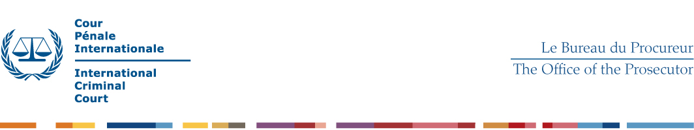
TERMS OF REFERENCE – SGBC Investigators

- Operational Context

The position of the Expert is located within a Unified Team of the Office of the Prosecutor of the ICC. The Unified Teams are comprised of investigators, analysts and lawyers and have the responsibility of investigating and prosecuting the crimes committed in the context of a situation under investigation. Within the Unified Teams, investigators are responsible for objectively and independently conduct evidence collection activities to further the investigation towards establishing the truth, while ensuring proper witness and information management.

- Tasks

Under the direct supervision of the investigation Team Leader, the Expert is expected to:

General profile

- collect, screen and handle information and evidence in accordance with standard operating procedures;
- lead sensitive and complex interviews which require specialist skills and considerable experience such as the interviewing of particularly vulnerable witnesses, high level suspects and important overview witnesses;
- conduct the review and analysis of gathered materials and actively contribute to the evidence review and disclosure process;
- advise the Investigation Team Leader on investigation procedures and techniques to be used;
- participate in the preparation and timely review of investigation plans;
- manage contacts with external persons including victims, witnesses and intermediaries;
- plan, participate in, and lead field missions;
- be in charge of the development of leads and avenues of investigation;
- support the Team Leader in ensuring quality control, timely execution of tasks and full compliance with established practices in one or more core functions of the team
- provide expert advice on how to use existing international and other networks to further the investigations;
- support the Division in the development and implementation of strategic objectives and operational standards;
- give, pursuant to the instructions of the Team Leader, operational lead to other members of the Investigation Team, mentor junior staff and support the induction of new staff members;
- testify before the Chambers, if and when required;
- perform other duties as required.

SGBC expert

- Research, review and analyse jurisprudence, legislation, reports and academic articles, as well as other types of relevant sources of information relevant to the topics of SGBC, ensuring the Office has insight into the latest thinking, ongoing challenges and recent judicial decisions in this innovative and ever growing area.
- Perform analytical tasks with a focus on SGBC and general gender analysis;
- Support managers and other members of the investigation team in adjusting the investigative strategy and operations to the needs and challenges of SGBC investigations and in identifying potential areas of evidence and investigative opportunities relevant to SGBC;
- Provide expert advice on how to develop and use existing international and other networks to further the investigations of SGBC;
- Support the collection of information and evidence in accordance with standard operating procedures relevant to the investigation and prosecution of SGBC;
- Participate in interviews of SGBC victims;
- Manage contacts with external persons including victims, witnesses and intermediaries;
- Support the Division in the development and implementation of strategic objectives and operational standards in the area of SGBC;
- Support lessons learnt and training activities to be conducted within the Office in the area of SGBC.

