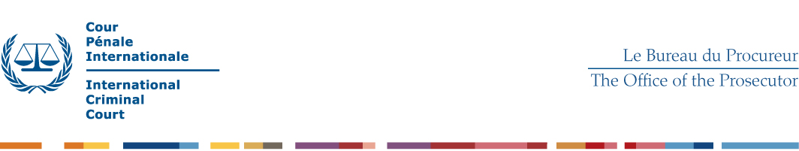
TERMS OF REFERENCE – Investigators

- Operational Context

The position of the Expert is located within a Unified Team of the Office of the Prosecutor of the ICC. The Unified Teams are comprised of investigators, analysts and lawyers and have the responsibility of investigating and prosecuting the crimes committed in the context of a situation under investigation. Within the Unified Teams, investigators are responsible for objectively and independently conduct evidence collection activities to further the investigation towards establishing the truth, while ensuring proper witness and information management.

- Tasks

Under the direct supervision of the investigation Team Leader, the Expert is expected to:
General profile
- collect, screen and handle information and evidence in accordance with standard operating procedures;
- lead sensitive and complex interviews which require specialist skills and considerable experience such as the interviewing of particularly vulnerable witnesses, high level suspects and important overview witnesses;
- conduct the review and analysis of gathered materials and actively contribute to the evidence review and disclosure process;
- advise the Investigation Team Leader on investigation procedures and techniques to be used;
- participate in the preparation and timely review of investigation plans;
- manage contacts with external persons including victims, witnesses and intermediaries;
- plan, participate in, and lead field missions;
- be in charge of the development of leads and avenues of investigation;
- support the Team Leader in ensuring quality control, timely execution of tasks and full compliance with established practices in one or more core functions of the team;
- provide expert advice on how to use existing international and other networks to further the investigations;
- support the Division in the development and implementation of strategic objectives and operational standards;
- give, pursuant to the instructions of the Team Leader, operational lead to other members of the Investigation Team, mentor junior staff and support the induction of new staff members;
- testify before the Chambers, if and when required;
- perform other duties as required.

- Qualifications and Skills

Education:
- Advanced university degree preferably in Law or Criminology. A first-level university degree in combination with two additional years of qualifying experience is accepted in lieu of the advanced university degree.

- A diploma in criminal investigation from a law enforcement academy and/or relevant training in crime investigation techniques, combined with 11 years of relevant experience may be considered in lieu of a university degree.
Experience:
- A minimum of 5 years (7 years with a first level university degree) of professional experience in criminal investigations within a law enforcement or judicial context, with a special focus on complex, large-scale cases.
- Or same level of professional experience working with NGO/IGO or International Commission of Inquiry, with a special focus on complex, large-scale cases.

Knowledge, skills and abilities:
- Expert knowledge of investigation techniques and procedures;
- Significant experience conducting investigative interviews of victims, witnesses and suspects;
- Experience in conducting or participating in complex investigations, with a particular emphasis on investigations of criminal networks, organised and/or transnational crimes, crimes committed in the context of armed conflicts and/or financial investigations;
- Experience in operating in risk or high-risk environments following strong security protocols;
- Experience in conducting open-source research and online investigations;
- Knowledge of the requirements of international criminal law concerning the elements of crimes and modes of liability;
- Excellent ability to organize complex and voluminous amounts of information and evidence;
- Excellent research, analytical and problem-solving skills, including familiarity with analysis techniques.
- Excellent ability to communicate effectively with police, NGOs, journalists or other relevant partners and networks;
- Ability to comply with high level confidentiality requirements;
- Ability to work under stressful conditions;
- Ability to demonstrate a high degree of flexibility and adaptability;
- Ability to work effectively in a multi-cultural and multi-disciplinary environment;
- Ability to work in a non-discriminatory manner, with respect for diversity;
- High professional and personal integrity standards.

Knowledge of Languages:

Proficiency in one of the working languages of the Court, English or French, is required. Working knowledge of the other is considered a strong asset. Knowledge of another official language of the Court (Arabic, Chinese, Russian and Spanish) is considered an asset.

